CIS 1111 Expressions Exercise 2 – 10 points
Description: For this assignment, you will build a program that gives cyber security recommendations & a pricing estimate for a company based on the number of computers they have on their network. Pricing is as follows and must be displayed to the user.
- $50 fee for each computer
- $125 for each firewall device
- $200 base consultation fee
Because this is a federal organization, there is no tax on these transactions.
Requirements:
Your program must do the following:
- Display pricing to the user.
- Ask the user how many computers they have on their network.
- Use the getline() function to collect the name of the company.
- For every 6 computers on the network, there must be one firewall device. To determine the number of firewall devices needed, use the ceil() function to round up to the nearest whole number. This ensures that even if there are leftover computers after grouping them in sets of 6, an additional firewall device will be included.
- Calculate the total cost to give the user a full cyber security solution and display it to them as an itemized invoice.
- Program must be documented with:
  - //Name
  - //Date
  - //Program Name
  - //Program Description
Sample output:
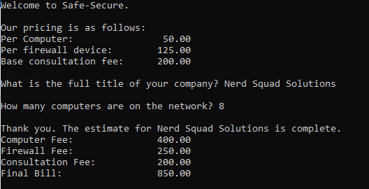
Sample Test Data:
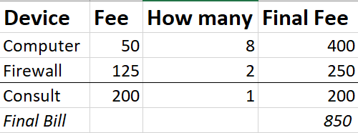

Submission Requirements:
Upload the following to the drop box:
- Your .cpp file
- Screenshot of your output and program code
- Your test data

Grading rubric for this assignment:
 | Low End (did not do or very little effort) | High End (Requirements met with high effort)
Program successfully compiles | 0 | 1
Meets all program requirements | 0 | 5
Properly submitted all required files to the drop box | 0 | 4

